**SMAET EGG INCUBATOR**

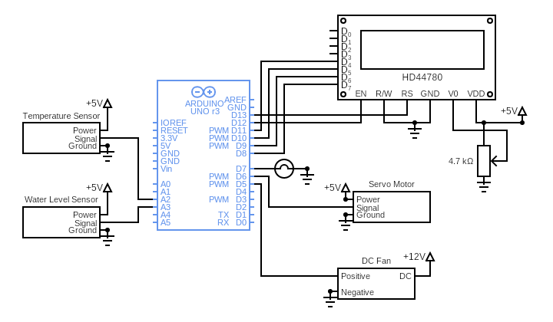

**Working of components**

**Arduino UNO Board:**

The user can get started by connecting the Uno to a computer with the USB cable or by powering it with an AC / DC adapter or battery. The Uno can be programmed with Arduino Software (Integrated Development Environment). Arduino Uno features 14 digital input / output pins (six of which can be used as PWM outputs), six analog inputs, and a 16MHz quartz crystal. Uno also includes a USB connection, a power jack, an In- Circuit Serial Programming (ICSP) header, and a reset button. This Arduino MCU board contains everything the user needs to support the MCU.

**16x2 LCD:**

The LCD module is in connection with D8 to D13 pins of Arduino. An LCD (Liquid Crystal Display) screen is an electronic display module and has a wide range of applications. A 16x2 LCD display is very basic module and is very commonly used in various devices and circuits. A 16x2 LCD means it can display 16 characters per line and there are 2 such lines. In this LCD each character is displayed in 5x7 pixel matrix. The 16 x 2 intelligent alphanumeric dot matrix display is capable of displaying 224 different characters and symbols. This LCD has two registers, namely, Command and Data.

Command registers stores various commands given to the display. Data register stores data to be displayed. The process of controlling the display involves putting the data that form the image of what you want to display into the data registers, then putting instructions in the instruction register. In your Arduino project Liquid Crystal Library simplifies this for you so you don't need to know the low-level instructions. Contrast of the display can be adjusted by adjusting the potentiometer to be connected across VEE pin.

**Temperature sensor:**

The temperature sensor is connected to the A2 pin of Arduino. Temperature sensors are devices to measure temperature readings through electrical signals. The sensor is made up of two metals, which generate electrical voltage or resistance once it notices a change in temperature. The temperature sensor plays a critical role in maintaining a specific temperature within any equipment used to make anything from medicine to beer. To produce these types of content, the accuracy and responsiveness of the temperature and temperature control are critical to ensuring the end product is perfect. Temperature is the most common physical measurement type in industrial applications. Accurate measurements are vital in ensuring the success of these processes.

The basic principle of working of the temperature sensors is the voltage across the diode terminals. If the voltage increases, the temperature also rises, followed by a voltage drop between the transistor terminals of base and emitter in a diode.

**Water Level Sensor:**

The water level sensor is connected to the A3 pin of Arduino. The working of the water level sensor is pretty straightforward. The series of exposed parallel conductors, together acts as a variable resistor (just like a potentiometer) whose resistance varies according to the water level. The change in resistance corresponds to the distance from the top of the sensor to the surface of the water. The resistance is inversely proportional to the height of the water. The more water the sensor is immersed in, results in better conductivity and will result in a lower resistance. The less water the sensor is immersed in, results in poor conductivity and will result in a higher resistance. The sensor produces an output voltage according to the resistance, which by measuring we can determine the water level.

**DC fan:**

The DC fan is connected to the D5 pin of Arduino. A DC ceiling fan works pretty much on the same principle as the DC motor. A DC motor uses an internal arrangement of magnets with opposing polarity. As current passes through the coil around this arrangement, a strong magnetic field is produced. This magnetic field then creates a torque that causes the motor to rotate. Ceiling fans specifically use the brushless DC motor, that is, the synchronous DC motor.

DC motors require less electrical energy and help to minimize power consumption up to 70%.

**Servo Motor:**

The servo motor is connected to the D6 pin of Arduino. A servo consists of a Motor (DC or AC), a potentiometer, gear assembly, and a controlling circuit. First of all, we use gear assembly to reduce RPM and to increase torque of the motor. Say at initial position of servo motor shaft, the position of the potentiometer knob is such that there is no electrical signal generated at the output port of the potentiometer. Now an electrical signal is given to another input terminal of the error detector amplifier. Now the difference between these two signals, one comes from the potentiometer and another comes from other sources, will be processed in a feedback mechanism and output will be provided in terms of error signal. This error signal acts as the input for motor and motor starts rotating. Now motor shaft is connected with the potentiometer and as the motor rotates so the potentiometer and it will generate a signal. So as the potentiometer’s angular position changes, its output feedback signal changes. After sometime the position of potentiometer reaches at a position that the output of potentiometer is same as external signal provided. At this condition, there will be no output signal from the amplifier to the motor input as there is no difference between external applied signal and the signal generated at potentiometer, and in this situation motor stops rotating.

**Incandescent light:**

The incandescent light is connected to the D7 pin of Arduino. When an object is made hot, the atoms inside the object become thermally excited. If the object does not melt, the outer orbit electrons of the atoms jump to higher energy level due to the supplied energy. The electrons on these higher energy levels are not stable, they again fall back to lower energy levels. While falling from higher to lower energy levels, the electrons release their extra energy in a form of photons. These photons are then emitted from the surface of the object in the form of electromagnetic radiation.

This radiation will have different wavelengths. A portion of the wavelengths is in the visible range of wavelengths, and a significant portion of wavelengths are in infrared range. The electromagnetic wave with wavelengths within the range of infrared is heat energy and the electromagnetic wave with wavelengths within visible range is light energy.

Incandescent means producing visible light by heating an object. An incandescent lamp works in the same principle. The simplest form of the artificial source of light using electricity is an incandescent lamp. Here we use electric current to flow through a thin and fine filament to produce visible light. The current rises the temperature of the filament to such extent that it becomes luminous.

**Potentiometer:**

The potentiometer is connected to the Vo pin of the LCD. Here it is used to control the contrast of the LCD screen. Potentiometers work by varying the position of a sliding contact across a uniform resistance. A potentiometer has the two terminals of the input source fixed to the end of the resistor. To adjust the output voltage the sliding contact gets moved along the resistor on the output side.